APPLECROSS SENIOR HIGH SCHOOL
Year 12 Human Biology Test 2
(in addition to extended answer question)

DO NOT WRITE ON TEST PAPER

PART 1 Choose the best alternative and answer on multiple choice answer sheet.

1. This question refers to the list of statements below.

(i) The fossil record has some specimens that form a link between modern varieties of some species.
(ii) Animal breeders are able to produce a large number of different breeds.
- DNA analysis demonstrates that related species show much similarity in the sequence of their DNA.
- The upper limb of many vertebrates display similar patterns.

Which of the above statements provide evidence to support the theory of evolution?

- (i) and (ii) only
- (i), (ii) and (iii) only
- (i), and (iv) only
- (i), (ii), (iii) and (iv)

2. It in not absolutely certain whether a trait has survival value or not. This depends on the:

(a) adaptation
(b) variation
(c) colour
(d) environment

3. Identify the CORRECT statement about evolution.

(a) Evolution can occur in a population without causing any change in gene frequencies
(b) The development of resistance to antibiotics by bacteria is an example of evolution.
(c) The development of new features occurs when a species settles into new, uninhabited territory.
(d) Random genetic drift occurs more readily in large populations.

4. A scientist visiting some offshore islands identified 10 different species of butterflies. The scientist concluded that these had descended from an original population that arrived from the mainland and then spread throughout the islands.
Which of the following would account for the development of the 10 species of butterfly?

- The different butterfly populations where able to interbreed freely.
- There was variation between individuals in the original population.
- There was little variation among habitats on the islands
- The original population was not typical of the mainland butterflies.

5. Charles Darwin contribution to evolutionary science was to provide a logical explanation for evolution. Critics often cite a single error, or one aspect that could not be explained at the time. One such aspect that Darwin could NOT explain (but was explained successfully later by another “scientist”) was the:

(a) reason why natural selection occurred
(b) origins of variation
(c) selection process of favourable variations
(d) role the organism’s surroundings played

6. A mutation is a sudden change in the structure of a gene. Scientist link mutations to the process of natural selection very closely. Mutations

(a) always produce beneficial variations upon which natural selection can act.
(b) are of importance to natural selection only if they can pass from generation to
generation.
(c) will improve the survival chances of an individual.
(d) result in random genetic drift.

7. Which of the following is NOT an essential component in the formation of a new species?

(a) Variation among individuals in a population
(b) Reproductive isolation
(c) A high rate of mutation
(d) A change in the genetic composition of a population

8. Random genetic drift has the greatest evolutionary effect in breeding populations that are relatively:

(a) small and isolated
(b) large and isolated
(c) small but not isolated
(d) large but not isolated

9. A small island in the Pacific was studied and the population was found to carry an abnormally high frequency for the gene causing Achromatoplasia (absence of colour vision). Scientists concluded that his was due to random genetic drift.

Which of the following is the best example of how random genetic drift may have caused this result?

(a) A cyclone struck the island suddenly. Most of the survivors carried the gene for
Achromatoplasia.
(b) The gene for Achromatoplasia gives a survival advantage to those who possess it.
(c) Those who carry this gene are more likely to find mates and more likely to have
children.
(d) There has been a large growth of the population in recent years.

10. “Gene flow” and “migration: are often used interchangeably. Why this is NOT so can be explained by the fact that:

(a) a person can migrate without passing on any alleles
(b) a person migrates and passes on new alleles
(c) your alleles move only when you do
(d) different populations have different alleles

11. Gene flow (GF) may introduce new alleles into a population, while random genetic drift (RGD) may involve the loss of alleles from a population. Based on this assumption, how does each affect variation in a population?

 |  | Variation
(a) | GF  RGD | Decrease  Increase
(b) | GF  RGD | No change  No change
(c) | GF  RGD | Increase  Decrease
(d) | GF  RGD | No change  Decrease

12. Darwin’s argument of “descent with modification” (evolution) is based on four main parts, which of the following is NOT one of these parts?

(a) organisms differ from each other in ways that are inherited
(b) more are born than can survive
(c) selection leads to the accumulation of favoured variant forms
(d) organisms develop/adjust to their environment by the process of acquired
characteristics

13. Comparative studies in humans and apes show they are closely related. The molecular data show that Homo (the human genus) and Pan (the chimpanzee genus) are identical in 99.6% of their amino acid sequences and 98.4% of their DNA nucleotide sequence. This genetic correspondence supports other evidence that suggest:

(a) Homo are descendants of Pan
(b) Homo and Pan descended from Gorillas
(c) An increase in molecular evolution
(d) Homo and Pan share a common ancestor

14. The fossil record show a gradual change in life forms over a long period of time. Generally this change is from:

(a) less intelligent to more intelligent forms
(b) simple to more complex forms
(c) four-limbed to two-limbed forms
(d) shorter to taller forms

15. The diagram below shows the appearance of the bones in a number of vertebrate limbs. A comparison of these limbs is used to support the theory of evolution because such comparisons demonstrate

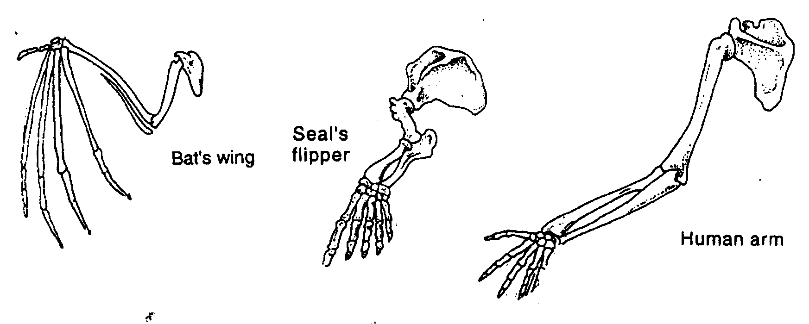

(a) inheritance of acquired characteristics.
(b) the variations from a common structure relate to a different way of life.
(c) that similar structures will arise form different ancestors.
(d) a fossil record that shows all vertebrates come from similar environments.

16. An association between human physical characteristics and the environment, was first noticed by the ancient Greeks. People from central Africa were discovered to have dark skin, and it was assumed that the difference was caused by the intensity of the tropical sun. This characteristic is an example of a/an:

(a) migratory population
(b) mutation
(c) adaptation
(d) variation

17. Which of the following would NOT contribute to the extinction of a species?

(a) environment changes rapidly
(b) no appropriate genetic variation
(c) other species with the same requirements become better adapted
(d) abundant resources such as food

18. Different populations may be reproductively isolated from each other – by one or more barriers. Which of the following is NOT a socio-cultural barrier?

(a) economic status
(b) mountain ranges
(c) educational background
(d) religious belief

19. In the Congo (West Africa) individuals who are homozygous dominant, for normal red blood cell shape, are more susceptible to malaria; those who are homozygous recessive have sickle-cell anaemia (where the red blood cell shape is in the form of a crescent) and often die. However, those that are heterozygous are less susceptible to malaria and do not have sickle-cell anaemia. Heterozygous individuals are common in West Africa. This is an example of:

(a) natural selection
(b) random genetic drift
(c) speciation
(d) founder effect

20. Vestigial organs are structures:

(a) of increased size that function more efficiently than normal sized organs
(b) only exist in ancestoral forms
(c) are unique to humans
(d) of reduced size that appear to have no function
(20 marks)

